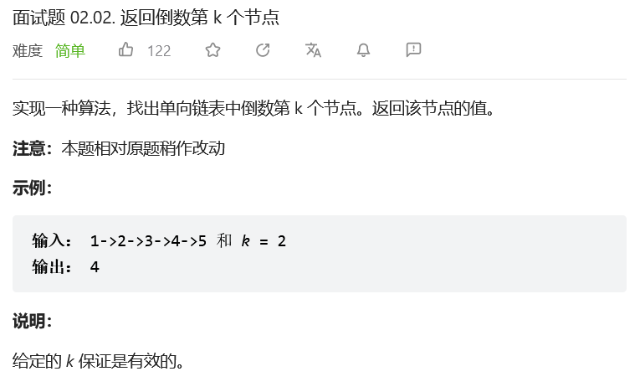
方法一：双指针
初始化双指针 pre , cur 都指向头节点 head ；
先令 cur 走 kk 步，此时 pre , cur 的距离为 kk ；
令 pre , cur 一起走，直到 cur 走过尾节点时跳出，此时 pre 指向「倒数第 kk 个节点」，返回之即可；
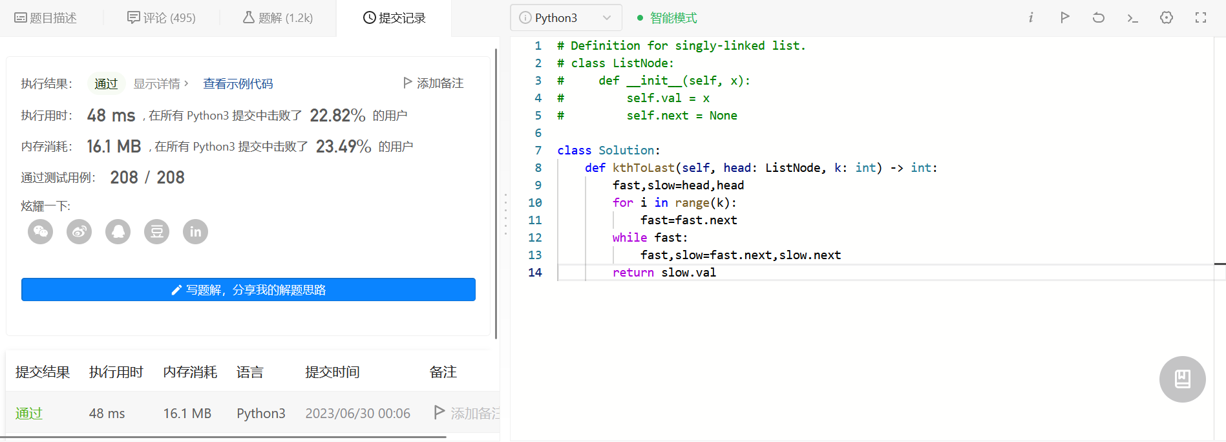

方法二：递归
class Solution:
def kthToLast(self, head: ListNode, k: int) -> int:
#递归
self.size = 0
def recurr(head , k):
if head == None: return 0

val = recurr(head.next , k)
self.size += 1
if self.size < k:return 0
elif self.size == k:return head.val
else:return val
return recurr(head,k)

方法三：栈
class Solution:
def kthToLast(self, head: ListNode, k: int) -> int:
#栈
stack = []
cur = head
while cur:
stack.append(cur.val)
cur = cur.next
return stack.pop(-k)
